|  |
| --- |
| DAY 9 ASSIGNMENTS BY LOKESH NADELLA |

1. WRITE A C# PROGRAM TO READ INPUT FROM USER AND PRINT?

A,factorial of number

b.factors of number

c.check if it prime or not?

using System;

using System.Collections.Generic;

using System.Linq;

using System.Text;

using System.Threading.Tasks;

namespace day9_project1

{

class Operations

{

private int input;

public void ReadInput()

{

Console.WriteLine("Enter number: ");

input = Convert.ToInt32(Console.ReadLine());

}

public int Factorial()

{

int fact = 1;

for (int i = 1; i <= input; i++)

{

fact = fact * i;

}

return fact;

}

public void Factors()

{

for (int i = 1; i <= input; i++)

{

if (input % i == 0)

Console.WriteLine(i);

}

}

public bool IsPrime()

{

int count = 0;

for (int i = 1; i < input; i++)

{

if (input % 1 == 0)

count++;

}

if (count == 2)

return true;

else

return false;

}

}

internal class Program

{

static void Main(string[] args)

{

Operations ob = new Operations();

ob.ReadInput();

Console.WriteLine(ob.Factorial());

ob.Factors();

if (ob.IsPrime())

Console.WriteLine("Input is PRIME Number");

else

Console.WriteLine("Not a Prime Number");

Console.ReadLine();

}

}

}

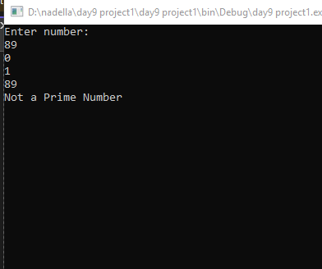

1. Write a c# program to read two numbers from user and print sum of two numbers, difference of two numbers,product of two numbers,division of two numbers?

using System;

using System.Collections.Generic;

using System.Linq;

using System.Text;

using System.Threading.Tasks;

namespace day9_project2

{

class ArithmeticOperations

{

private int a;

private int b;

public void ReadInput()

{

Console.WriteLine("Enter First Number: ");

a = Convert.ToInt32(Console.ReadLine());

Console.WriteLine("Enter Second Number: ");

b = Convert.ToInt32(Console.ReadLine());

}

public int AddNumbers()

{

return a + b;

}

public int Difference()

{

return a - b;

}

public int Product()

{

return a * b;

}

public int Division()

{

return a % b;

}

}

internal class Program

{

static void Main(string[] args)

{

ArithmeticOperations ar = new ArithmeticOperations();

ar.ReadInput();

Console.WriteLine(ar.AddNumbers());

Console.WriteLine(ar.Difference());

Console.WriteLine(ar.Product());

Console.WriteLine(ar.Division());

Console.ReadLine();

}

}

}

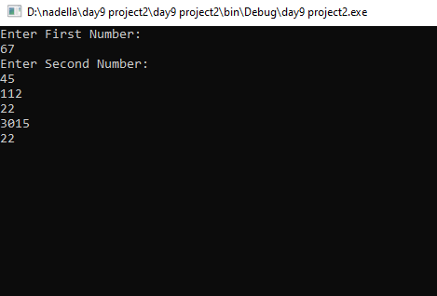

3.create employee class with two constructors as discussed in class?

using System;

using System.Collections.Generic;

using System.Linq;

using System.Text;

using System.Threading.Tasks;

namespace day9_project3

{

class Employee

{

public int id;

public string name;

public int salary;

public static string company = "NationsBenefits";

public Employee()

{

this.id = 0;

this.name = null;

}

public Employee(int eid, string ename, int esalary)

{

id = eid;

name = ename;

salary = esalary;

}

public void ReadData()

{

Console.WriteLine("Enter Employee ID: ");

id = Convert.ToInt32(Console.ReadLine());

Console.WriteLine("Enter Employee Name: ");

name = Console.ReadLine();

Console.WriteLine("Enter Employee Salary: ");

salary = Convert.ToInt32(Console.ReadLine());

company = "NationsBenifts";

}

public void PrintData()

{

Console.WriteLine($"Id:{id}, Name:{name}, Salary:{salary}, Company={company}");

}

}

internal class Program

{

static void Main(string[] args)

{

Employee emp = new Employee(1, "lokesh", 50000);

emp.PrintData();

Console.ReadLine();

}

}

}

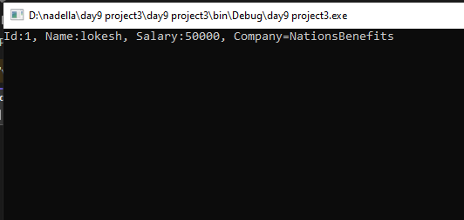

4.define constructor as we disscued in class?

1. A constructors is used to initialize class variables.

2. By default, C# has one constructor i.e., Default constructor to initialize class variables.

3. If user create user-defined constructor the default constructor will disappear.

4. Constructor name should be same as class name. If we use same variables as class variable use this. Keyword to differentiate class variable.

5. For a constructor, there should not be any return type not even void.

Eg : Public Employee(int id, string name)

5.create a employee class with variable

Id,name,salary,company and read data and print data??

using System;

using System.Collections.Generic;

using System.Linq;

using System.Text;

using System.Threading.Tasks;

namespace day9_project4

{

class Employee

{

public int id;

public string name;

public int salary;

public string company;

public void ReadData()

{

Console.WriteLine("Enter Employee ID: ");

id = Convert.ToInt32(Console.ReadLine());

Console.WriteLine("Enter Employee Name: ");

name = Console.ReadLine();

Console.WriteLine("Enter Employee Salary: ");

salary = Convert.ToInt32(Console.ReadLine());

company = "NationsBenifts";

}

public void PrintData()

{

Console.WriteLine($"Id:{id}, Name:{name}, Salary:{salary}, Company={company}");

}

}

internal class Program

{

static void Main(string[] args)

{

Employee emp1 = new Employee();

emp1.ReadData();

emp1.PrintData();

Employee emp2 = new Employee();

emp2.ReadData();

emp2.PrintData();

Console.ReadLine();

}

}

}

